Motherboard:

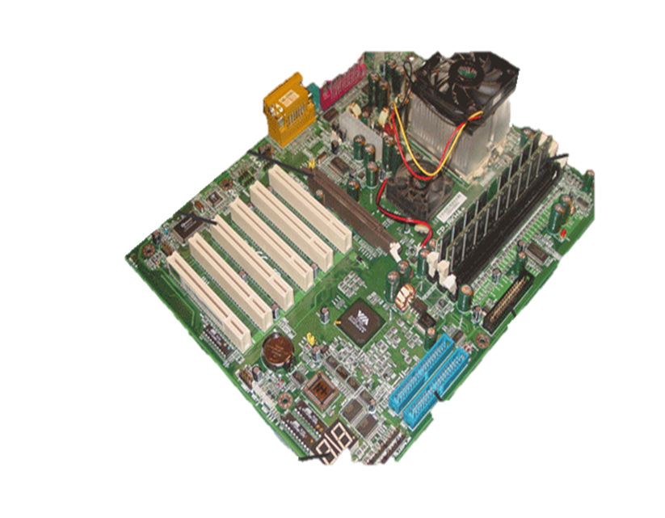
Activity:

Using the diagram above you have to research and identify each of these facilities and provide evidence of your research:

- On-Board Interfaces
.
- AGP Slot

- PCI bus

- Heatsink & Processor

- RAM

- HE34 (floppy interface)

- IDE interfaces

- POST

